

**MEDIA ADVISORY**PHOTO OPPORTUNITY**

**FOR Event: FOR INFORMATION CONTACT:**

Westlake Holiday Tree Nick Hawley, (206) 369-1960

Thursday, Dec. 4, (9:15a-11:00a) [nickh@downtownseattle.org](mailto:nickh@downtownseattle.org)

**Parking Carolers to Give Gift of Song, Free Parking at Holiday Tree**

Two Free Hours at First and Columbia Garage for Upcoming Shopping Events

SEATTLE—‘Tis the season for cheap parking, and the Parking Carolers (photo below), courtesy of WSDOT/[DowntownSeattleParking.com](http://www.downtownseattleparking.com/), will be singing and giving out coupons for **two free hours of parking**. During December, these coupons can be redeemed for 2-hour vouchers for use at First and Columbia garage. Drivers just need to park in the garage, and walk to MilePost 31, the Alaskan Way Viaduct Replacement exhibit space (211 First Ave. S), to obtain a voucher (hours: Tues-Sat, 11a-5p).

This promotion coincides with Shop the Square, Pioneer Square’s Saturdays of discounted shopping, culminating with the Howlidays Dog Parade on Dec. 13.

**What:** Parking carolers in garb, handing out coupons for 2 hours of free parking, and singing custom-written parking jingles.

**When:** Thursday, December 4, 9:15a-11:00a

**Where:** Westlake Holiday Tree, Downtown Seattle

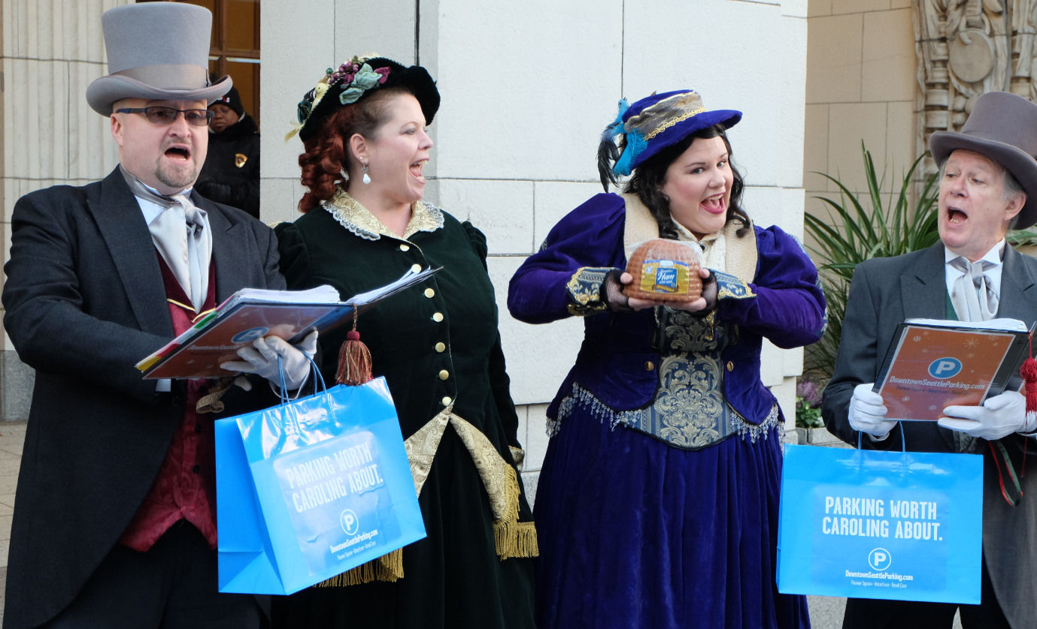

**More Info:**

This season, more than 6,500 discounted, short-term parking spaces are available just a few steps from holiday festivities, shopping, dining, music and events.

Pioneer Square and Waterfront garages have rates of $3 an hour for up to four hours. Retail Core garages such as Union Square are now offering low evening and weekend rates of $7 or less.

Drivers can pinpoint available spots 24/7 through [DowntownSeattleParking.com](http://www.downtownseattleparking.com). Launched in July 2013, the mobile site now serves roughly 1,100 users each day.

*The mobile site (DowntownSeattleParking.com) is part of a larger effort to help drivers find parking in Pioneer Square and the waterfront during Alaskan Way Viaduct Replacement Program construction. Led by the Washington State Department of Transportation, the City of Seattle and Downtown Seattle Association, the* [*parking mitigation program*](http://www.wsdot.wa.gov/Projects/Viaduct/Traffic/ParkingInformation) *helps maintain the vitality of Pioneer Square and the waterfront as major commerce hubs and tourist destinations.*